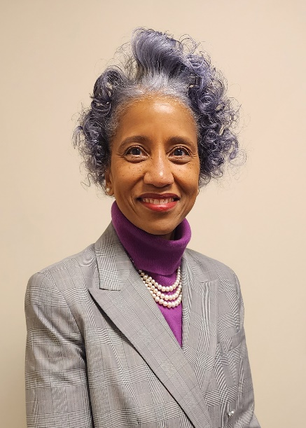

**Gwendolyn Sykes**

Executive Vice President, Finance and Chief Financial Officer, SRC, Inc.  
Treasurer, SRC International Board of Directors

Gwendolyn Sykes is Executive Vice President, Finance and Chief financial officer at SRC, Inc. and serves as Treasurer for the SRC International board of directors.

Sykes directs investment management, pricing and cost analysis, and financial analyses of budgets, forecasts, and results. She also reviews potential new acquisitions and communicates SRC’s financial results to the company president, executive management, and board of trustees.

Prior to SRC, Sykes was CFO at the U.S. Secret Service. Before that, she was the first female to serve as a Political Appointee/Senate confirmed chief financial officer for the National Aeronautics and Space Administration. Sykes has also served as the chief financial officer at two academic enterprises – Yale University and Morehouse College. She has been recognized for her achievements by the National Academy of Public Administrators, Newsweek, the Today Show and the Association of Government Accountants.

Sykes holds a bachelor’s degree in accounting from Catholic University and a master’s degree in public administration from American University, where she continues to serve as an adjunct professor in the School of Public Affairs. In May of 2022, Wilson College conferred upon her an Honorary Doctor of Humane Letters.