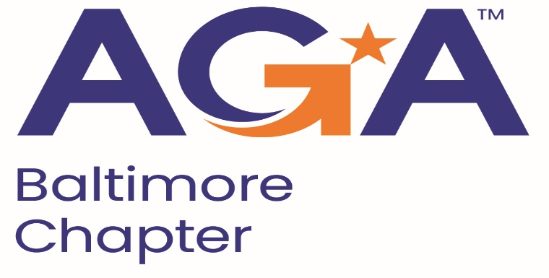

**Board of Directors Meeting Agenda**

April 17, 2024

2:00 – 3:00PM

Call-in Number: 1-443-840-7262

Participant Code: 870 559 635 #

1. **Call to Order**
   1. **Jamie Richardson, Mike Klausmeier, Joann Burnett, Kyle Brincefield, Kristen Schnatterly, Megan Salter, Shenika Smith, Johnny Ramsey**
2. **Review and Approval of Prior Minutes**
   1. **Joann motion to approve, Megan second. Minutes Approved.**
3. **President’s Report** 
   1. **Speakers for Maritime are set, Megan has the agenda set up and shared it with the board to show the schedule.**
4. **NCC Introduction and Update**
5. **Treasurer Update**
6. **Committee Updates**

* **Accountability** (Amanda)
* **Awards** (Kristina and Angela)
* **Activities/Ace Reporting** (Lori)
* **CGFM/Certifications** (Kristen and Aurelie)
* **Communications/Webmaster** (Shenika)
* **Community Service/Social Events** (Sarah)
* **Education** (JoAnn, Jamila, Kelly, Johnny)
* **Meetings** (Megan, Kyle)
* **Membership** (Geoff and Masoud)
* **Sponsorships** (Colleen)
* **Students/Young Professionals** (Renee)

**VI. New Business**