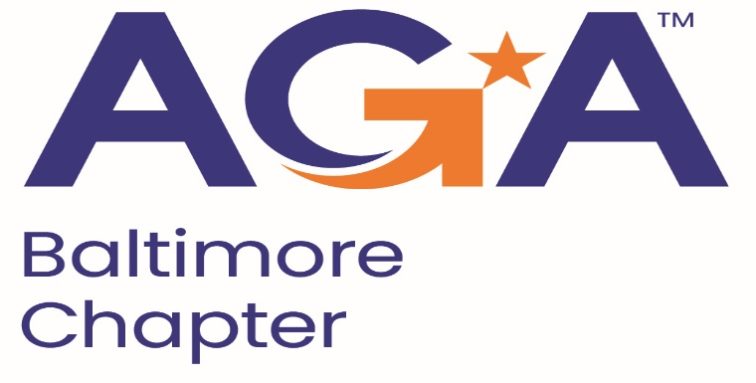

**Board of Directors Meeting Agenda**

August 14, 2024

11:00AM – 12:00PM

Call-in Number: 1-443-840-7262

Participant Code: 193 965 47#

1. **Call to Order**

Jamie Richardson, Shenika Smith, Richard Merritt, Kristen Schnatterly, Lori Lee, John Goodwin, Megan Salter, Angela Shields, Johnny Ramsey, Mike Klausmeier

1. **Review and Approval of Prior Minutes**

Mike made motion to approve, Lori seconded. Prior meeting minutes approved.

1. **President’s Report**

* Committee Chairs, we will have the same format as last years committees, however, the combination of membership and young professionals will occur this year, Masoud and Geoff have taken on those rolls.
* We have all committee chairs filled, however, we are always looking for additional volunteers.
* Shenika would like for our chapter to become a Top Platinum chapter, increase of outreach in our communities (national and local), and accelerate our members with learning specially CGFM credentialling.
* Shenika will be reaching out to committee members (like a pulse check) monthly, or bimonthly to ensure all is taken care of and if there is anything needed from the board or Shenika herself.
* Membership matters survey to get out to members by November and then another one in May to see performance.
* Shenika is implementing a nominating committee for the upcoming program year.
* Shenika would like to create a calendar of events for the entire program year that can be placed on the website for all members to see, to ensure less conflict in scheduling events.
* ACE goal specific items will be sent to each committee chair to ensure we will reach those points this year.

1. **NCC Introduction and Update (Kristen)**

* NCC meeting last Wednesday (August 7).
* Lots of materials for committees on the national website, let Kristen know if you are trying to find specific items that are not easily accessible.
* Reach out to Kristen if you need assistance with what other chapters are doing and how we can do better with our roles.
* Young Professionals: spoke about allowing college students to be invited to Board meetings – No commitment required for them.

1. **Treasurer Update** (Mike)

* Working on moving all bank accounts to the new treasurer.
* About $34,000 in our main checking accounts, $17,000 in our CD, and around $6,000 in our PayPal account.
* Proposed budget was presented.
  + CGFM expenses: Kristen wanted to make it known that there is a potential that there will be no expenses during the year or the expense could be used anytime in the year.
* Mike - motion to approve the budget, Jamie seconded. Proposed budget is approved.

1. **Committee Updates**

* **Accountability**(Mike)
  + Joint Peer review with Dallas and potentially Delaware at the end of the year. We have until the end of October to complete the CCR, Mike and Shenika will coordinate to complete this.
* **Activities/Ace Reporting** (Lori)
  + First submission is November 1st, Lori/Shenika will reach out to members before submission.
* **Administration**(Kelly)
  + State filing were completed in the spring and Lori uploaded the filing for points. Megan will need to send Kelly the NASBA information for renew before the deadline.
* **Awards** (Renee)
  + N/A
* **Bylaws** (Mike)
  + Pulled nationals Bylaws off the website and compare them with ours, Mike will complete the comparison and send it to the board for approve once complete.
* **CGFM/Certifications** (Kristen and Aurelie)
  + CGFM presentations twice a year (November will be the first, if available)
* **Communications/Webmaster** (Shenika)
  + Contact list for MailChimp has been updated with the latest membership report on National. Access to the google drive is available to Shenika and Jamie.
  + Domain renewal is on August 18.
  + Newsblast template has been created and will be filled with information for each distribution. Distribution will be Sept, Dec, March, and June.
  + Website is being wiped and updated with current and relevant information.
* **Community Service**(Angela)
  + Determining what to do with our budget.
  + Happy Helpers is a main volunteer opportunity we like to take part in during the year.
  + List of community service activities we can do this year will be sent out by Angela.
  + National asked us to be involved in the Chapter Challenge and a gift card for PDT (Roughly $300).
  + International Volunteer day: UN General Assembly, Thursday Dec. 5. Choose a few members and provide a thank you to them.
  + Looking at adding back in the Kingsville Men as a 501 C3 charity for our chapter, we will need to look into it to ensure they are a 501 C3 and not a 501 C2 as they were in the past.
* **Education** (John, Johnny, Kelly)
  + Next steps are getting out training topics by the beginning of September for each training and coordinating with Kearney and Company for the September 18 training.
* **Meetings** (Megan)
  + Once the topic and speakers for the September meeting are determined, send the information to Megan to get the flyer ready and distributed.
* **Membership/Young Professionals** (Masoud and Geoff)
  + N/A
* **Social Programs**(Mike)
  + Potential Events
    - Crab Feast with Johnny Ramsey’s church (September 28)
      * We discussed subsidizing a price for AGA members ($35). First 10 people to sign up will pay $35 and the Chapter will pay the other $35 ($350 total, only paying for member not additional people).
      * Need to know by September 18 for who wants to attend, reminder will be stated at the September meeting.
    - Happy Hours throughout the year (Potentially Holiday type)
    - Setting up a wine tour
    - Orioles game in the Spring
* **Sponsorships** (Rich)
  + Determining what Sponsors want to get out of the membership and what benefits we will be giving them.

**VI. New Business**

* Sales tax exemption needs to be renewed by September 20, 2024.