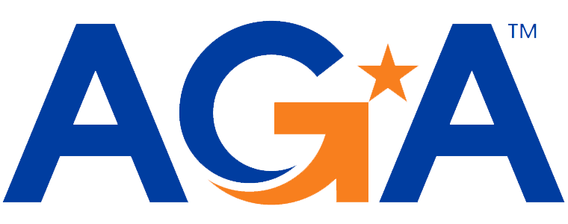

**Baltimore Chapter**

**Board of Directors Meeting Agenda**

August 16, 2023

2:00 – 3:00PM

Call-in Number: 1-443-840-7262

Participant Code: 723 989 805 #

1. **Call to Order**

*Mike Klausmeier, Lori Lee, Jamie Richardson, Shenika Smith, Megan Salter, Amanda Merlino, Aurelie Kamga, Kyle Brincefield, Johnny Ramsey, Kevin Lee*

1. **President’s Report** 
   1. Board Contact List:
      1. *Created subcategory for Johnny to be a College Liaison for the education committee. Shenika will be both webmaster and communications committee lead.*
   2. September 13, 2023 Acct Updates Training (AM Zoom session; 4hrs CPE):
      1. *Based on feedback, we are doing a half day training instead of a full 8-hour day and will adjust the February training according to how the training goes.*
      2. *Presenters are as follows: Steph Miller and Nino Pineres (E&Y) and Dave Zavada with Kearney and Co.*
   3. *Board meetings will be the third Wednesday of every month, except for August and September.*
2. **NCC Introduction and Update**
3. *No update.*
4. **2023-2024 Budget Discussion and Approval**
5. *Do we have the accounting from Last year? Yes, Kevin will send it out as a comparison for this year to last year.*
6. *Since we are only doing 4 CPEs for September the proceeds will be significantly less this year.*
7. *In July 2023, did we have $5,000 in proceeds in July? We had $9,000 in proceeds.*
8. *Johnny would like to have more explanation on what each of the expenses/proceeds mean.*
9. **Committee Updates**

* **Awards** (Kristina and Angela):
  + *No update.*
* **Activities/Ace Reporting** (Lori):
  + *Uploaded roaster and strategic goals. We will resubmit the contact list if we have any adjustments. First reporting for ACE points is November 1, 2023.*
* **Bylaws** (Mike)
  + *1 update on voting. Mike will make the update and send it to the board for approval. If we get the bylaws out by October 31 we will get 100 bonus points.*
* **CGFM/Certifications** (Kristen and Aurelie)
  + *No update.*
* **Communications/Webmaster** (Shenika)
  + *Received the member spotlight. Newsletter, we agreed to do a news blast instead of a newsletter last year (Quarterly). We will continue the news blast this year. Established a .org email and that is set to be renewed August 18, 2023. Renewal is $22.99, autorenewal will be set up with the card.*
* **Education** (Jamila, Kelly, Johnny)
  + *UMBC, Johnny will be teaching a course this year and will explain the opportunities AGA provides to student members.*
  + *Johnny has a check from the PO Box from Hampton Virginia that was paid to us at an event. Johnny and Kevin will meet to give the PO Box Key. Determine a process on how to get checks from the PO Box to Kevin.*
* **Meetings** (Megan, Kyle, JoAnn)
  + *Once the timing is verified for September meeting, Megan will send out the flyer. The drop form will be attached and will be able to register for it from the flyer. Costs will be the same this year as last year. $10 for CPE for members and $15 for CPEs for non-members (registering for the whole day will be a discounted rate).*
* **Membership** (Geoff and Masoud)
  + *Masoud was in a joint training session picnic with DC Northern Montgomery chapter and they invited our chapter to a function at the Glen Garland Park in Arlington, Virginia on September 16 at 11am.*
* **Social Events** (Kathleen)
  + *Upcoming social event after the September training.*
* **Sponsorships** (Colleen)
  + *No updates.*
* **Young Professionals** (Renee)
  + *No updates.*

**VI. New Business**

* *Johnny had spoken to a number of people at PDT and would like to bring forward a proposal for Milt Wolinski who served on the board for 40 years, he passed away in early July. Johnny would like to propose to name a scholarship after Milt Walinski in his memory.* 
  + *Johnny motioned, Megan and Shenika seconded the motion. Board voted and approved.*
  + *Could we do a News Blast on Milt? Idea was liked and Shenika and Mike will work on gathering information.*