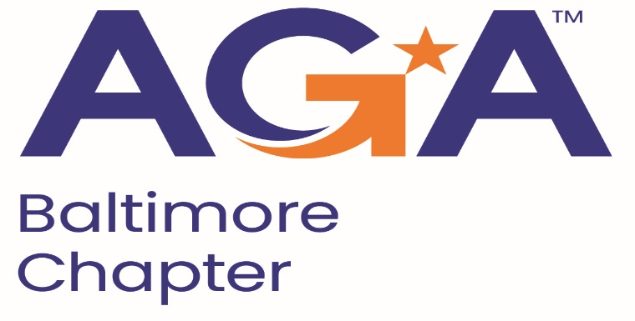

**Board of Directors Meeting Agenda**

February 21, 2024

2:00 – 3:00PM

Call-in Number: 1-443-840-7262

Participant Code: 870 559 635 #

1. **Call to Order**

Jamie Richardson, Mike Klausmeier, Masoud Najmabadi, Kristen Schnatterly, Renee Rawlins, Lori Lee, JoAnn Burnett, Megan Salter, Johnny Ramsey, Shenika Smith

1. **Review and Approval of Prior Minutes**

Motion to approve, seconded by Megan.

1. **President’s Report**

Training on emerging tools and technologies by E&Y on robots and AI for conducting audits. Planning on mid-March for this training.

Working on the flyer for the Fraud conference and get it out by March, the conference will be on May 15 at Maritime.

March is CGFM month and are going to host an event, likely on March 6.

1. **NCC Introduction and Update**

Reminder when we host our events, that they are posted on the AGA national site.

1. **Treasurer Update**
2. **Committee Updates**

* **Accountability** (Amanda)
* **Awards** (Kristina and Angela)
* **Activities/Ace Reporting** (Lori) Updated the ACE reporting for the end of January, next report will not be until after the Fraud conference in May for the final posting of the year.
* **CGFM/Certifications** (Kristen and Aurelie) Aurelie created a step by step guide for how to get the proclamations completed for Baltimore County and Baltimore city. We have received the proclamations back from Baltimore county. March 6 we will hold an informational meeting.
* **Communications/Webmaster** (Shenika)
* **Community Service/Social Events** (Sarah)
* **Education** (JoAnn, Jamila, Kelly, Johnny) Signed a contract with Mary Bronslyn as our ethics speaker. Consider sending out a Hold the Date for the Fraud conference since we do not have all of our speakers lined up yet. JoAnn trying to get the National President or President Elect.

In touch with the University of Baltimore to reestablish the relationship with the school for the AGA chapter. Johnny is speaking to UB next Wednesday.

* **Meetings** (Megan, Kyle) Created the Jotform and Zoom meeting for the CGFM meeting on March 6 and started working on the flyer for the event. Signed the Maritime contract for the Fraud Conference.
* **Membership** (Geoff and Masoud) Since last month we have 3 new members, putting us at 23 new members for this fiscal year. We have a total of 183 as of the end of January. Masoud is planning to send an email to members to invite others to the chapter by the end of the month.
* **Sponsorships** (Colleen)
* **Students/Young Professionals** (Renee)

**VI. New Business**

* Transfer of the Bank Account information.
* Updated Financials for this year.
* Have we been monitoring where we are for the ACE points? Yes we are on track for platinum.
* National provides half price for dues and meetings for retirees, have we considered this for the chapter? We can look to see what other chapters do and see if we should do this for our chapter. Kristen will reach out to other chapters in our region.