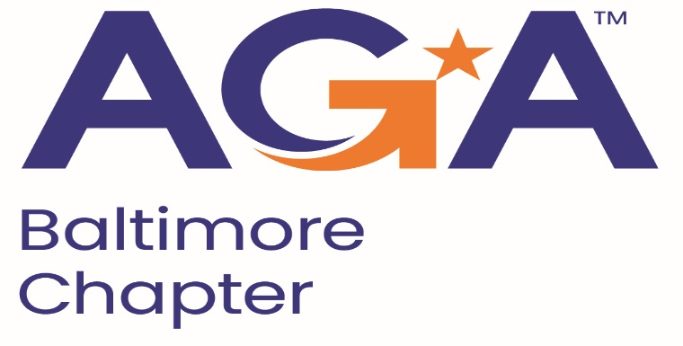

**Board of Directors Meeting Agenda**

January 17, 2024

2:00 – 3:00PM

Call-in Number: 1-443-840-7262

Participant Code: 870 559 635 #

1. **Call to Order**
2. **Review and Approval of Prior Minutes**
3. **President’s Report**
4. **NCC Introduction and Update**
5. **Treasurer Update**
6. **Committee Updates**

* **Accountability** (Amanda)
* **Awards** (Kristina and Angela)
* **Activities/Ace Reporting** (Lori)
* **CGFM/Certifications** (Kristen and Aurelie) March is CGFM month. Kristen and Aurelie have been working with Megan and Kyle to set up and host a CGFM informational session via Zoom on **March 6, 2024.**
* **Communications/Webmaster** (Shenika) We sent photos and a brief writeup to Shenika from the Happy Helpers event which Shenika posted on our page and sent via email.
* **Community Service/Social Events** (Sarah)
* **Education** (JoAnn, Jamila, Kelly, Johnny) JoAnn has an ethics speaker for the 5/15 Fraud Conference morning session (confirmed via email vote) and a speaker for the afternoon. We will lock in our remaining speakers (JoAnn and Mike working together on remaining speakers). We will also host a training session on *Emerging Trends, Tools Technologies* in March. E+Y will be one of our presenters on robotics and AI in auditing. Mike is perusing other firms to see if they are also interested in presenting on a similar topic.

Finally, Johnny and Kyle have incorporated AGA Baltimore into recruiting at UMBC.

* **Meetings** (Megan, Kyle) Megan and Kyle re working on setting up the March CGFM training presentation via Zoom.
* **Membership** (Geoff and Masoud)
* **Sponsorships** (Colleen)
* **Students/Young Professionals** (Renee)

1. **New Business**

We confirmed upcoming officers for ’24-’25 on 2/15/2024, in accordance with the Bylaws. Board notified via email.