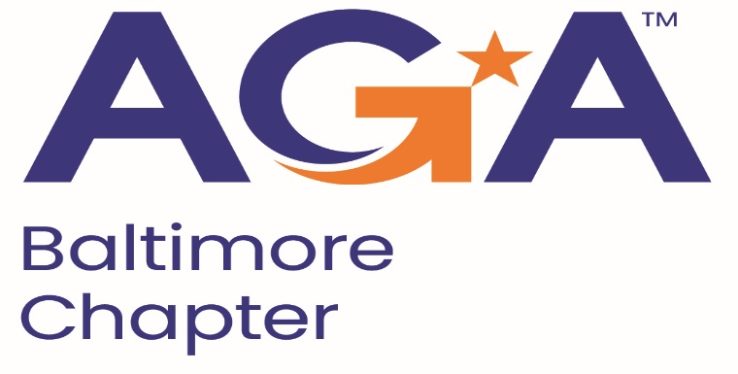

**Board of Directors Meeting Agenda**

March 20, 2024

2:00 – 3:00PM

Call-in Number: 1-443-840-7262

Participant Code: 870 559 635 #

1. **Call to Order**

Mike Klausmeier, Lori Lee, Johnny Ramsey, Kristen Schnatterly, Jamie Richardson, Shenika Smith, Aurelie Kamga, JoAnn Burnett

1. **Review and Approval of Prior Minutes**

Motion to approve, Shenika seconds.

1. **President’s Report**

Financial Review with Dallas is being worked on by Mike. Nicholas Gerard, area director for AGA, reached out to the Mid-Atlantic area AGA’s to complete a review of the Chapter of Delaware Financial, Mike is going to complete this for them.

With the Budget for the Government entities, we are having difficulties getting people to attend meetings as they are not being approved due to budget limitations.

1. **NCC Introduction and Update**

Reached out to Nick about the retired members discount, a few chapters confirmed they did not offer discounts but AGA national is offering a reduced PDT rate for retired members, $500.

1. **Committee Updates**

* **Accountability** (Amanda)
* **Awards** (Kristina and Angela)
* **Activities/Ace Reporting** (Lori)

Reporting period ends May 1. We will anticipate what we complete in May to get the points. Possible amount of points for people serving on the National Committee, Johnny is a part of the higher education committee.

* **CGFM/Certifications** (Kristen and Aurelie)

Upcoming informational session on March 27.

* **Communications/Webmaster** (Shenika)

Posting has been made on all Social Media accounts for the CGFM session next week. Will be sending out an email in addition. Get an email/social media information out about April 4th meeting from E&Y on emerging trends for 1 CPE/1Hour.

* **Education** (JoAnn, Jamila, Kelly, Johnny)

We have the Ethics speaker for May. Second speaker, Gwynn Sykes, AGA National President. Rick Henry, IG of Education in Maryland. State of Maryland Attorney General speaker. Plan to get out an Agenda by the end of March for May 15th Fraud Conference. Put out a Save the Date on Social Media/Email ASAP.

* **Meetings** (Megan, Kyle)
* **Membership** (Geoff and Masoud)
* **Sponsorships** (Colleen)
* **Students/Young Professionals** (Renee)

**VI. New Business**