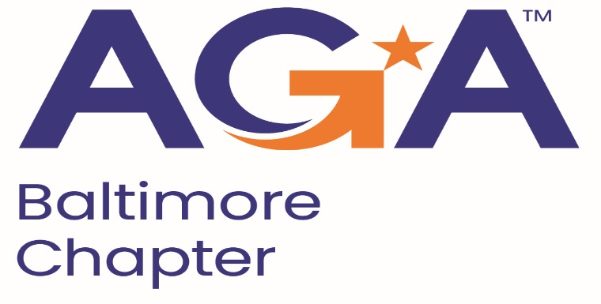

**Board of Directors Meeting Agenda**

November 15, 2023

2:00 – 3:00PM

Call-in Number: 1-443-840-7262

Participant Code: 870 559 635 #

1. **Call to Order**

*Mike Klausmeier, Jamie Richardson, Aurelie Kamga, Sarah Cherry, Kyle Brincefield*

1. **Review and Approval of Prior Minutes**

*Motion to approve, Aurelie second.*

1. **President’s Report**

*Community service event on Saturday, November 18 at 11:30am.*

1. **NCC Introduction and Update**

*No updates.*

1. **Treasurer Update**

*No updates.*

1. **Committee Updates**

* **Accountability** (Amanda)
  + *No updates.*
* **Awards** (Kristina and Angela)
  + *No updates.*
* **Activities/Ace Reporting** (Lori)
  + *No updates.*
* **CGFM/Certifications** (Kristen and Aurelie)
  + *No updates.*
* **Communications/Webmaster** (Shenika)
  + *No updates.*
* **Community Service/Social Events** (Sarah)
  + *No updates.*
* **Education** (JoAnn, Jamila, Kelly, Johnny)
  + *No updates.*
* **Meetings** (Megan, Kyle)
  + *Maritime is confirmed for May 15.*
* **Membership** (Geoff and Masoud)
  + *No updates.*
* **Sponsorships** (Colleen)
  + *No updates.*
* **Students/Young Professionals** (Renee)
  + *No updates.*

**VI. New Business**