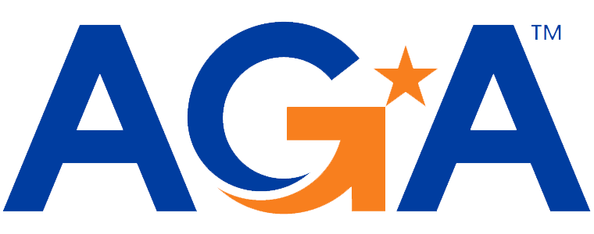

**Baltimore Chapter**

**Board of Directors Meeting Agenda**

October 18, 2023

2:00 – 3:00PM

Call-in Number: 1-443-840-7262

Participant Code: 870 559 635 #

1. **Call to Order**

*Michael Klausmeier, Jamie Richardson, Kristen Schnatterly, Renee Rawlins, Sarah Cherry, Shenika Smith, JoAnn Burnett*

1. **Review and Approval of Prior Minutes**

*Motion to approve, seconded by Renee. Approved.*

1. **President’s Report**

* *Based on the September meeting, the consensus was that 4 hours was liked better than doing an 8 hour meeting.*

1. **NCC Introduction and Update**

* *No updates. Next meeting is in the beginning of November.*

1. **Treasurer Update**

* *No updates.*

1. **Committee Updates**

* **Accountability** (Amanda)
  + *Working on the CCR. Due by the end of October.*
* **Awards** (Kristina and Angela)
  + *No updates.*
* **Activities/Ace Reporting** (Lori)
  + *Next pulse check on November 1, 2023.*
  + *Uploaded the most recent roster to national.*
* **Bylaws** (Mike)
  + *Added the director of sponsorships.*
  + *Motion to approve, Kristen seconded. Approved.*
* **CGFM/Certifications** (Kristen and Aurelie)
  + *No updates. Kristen normally reaches out for proclamations in January.*
* **Communications/Webmaster** (Shenika)
  + *Shenika was provided the refund amount for the email.*
  + *No later than the week of the 30th, Shenika will be sending out emails for our weekly posts.*
* **Community Service/Social Events** (Sarah)
  + *November 1 or November 2 for a social gathering and doing a Happy Helpers event (normally an October event).*
  + *Sarah can put together a flyer once a date is chosen.*
* **Education** (JoAnn, Jamila, Kelly, Johnny)
  + *Waiting for a date for Maritime to send information to a speaker.*
* **Meetings** (Megan, Kyle)
  + *All CPE certificates for September were set out.*
  + *Do speakers get CPE certificates for sessions they did not complete?*
    - *This is normally discussed before the training is held and Megan can have the certificate ready if they want one.*
* **Membership** (Geoff and Masoud)
  + *Have had new members join.*
  + *Rick Henry, Education IG for State of Maryland.*
* **Sponsorships** (Colleen)
  + *Perks for the Sponsorships were changed.* 
    - *For example, weekly insight from the firms that can be put on our social media and free tickets for trainings.*
  + *Invoices will be sent to the firms in the next two weeks.*
  + *Added Guidehouse as a potential sponsor.*
  + *Potential sponsors include: Guidehouse, E&Y, Grant Thornton, KPMG, Kearny and Company.*
* **Students/Young Professionals** (Renee)
  + *Amanda went to Loyola to talk with students.*
  + *We will work on setting up meet ups with students. (Johnny, Mike and Renee)*

**VI. New Business**

* *Holiday events: Is anyone opposed to not having a holiday event?*
  + *Look at the ACE awards to ensure we cover it another way.*
* *Do you get any invites from National for officers? -Question for Mike from Renee*
  + *No, have not received anything for Officers.*