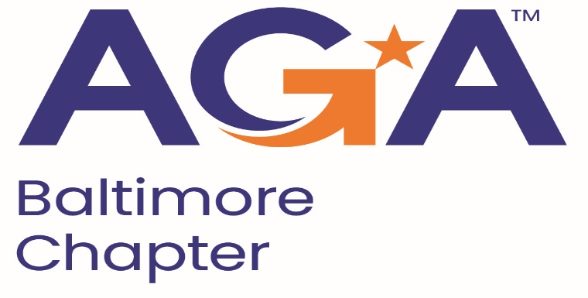

**Board of Directors Meeting Agenda**

October 9, 2024

11:00AM – 12:00PM

Call-in Number: 1-443-840-7262

Participant Code: 193 965 47#

1. **Call to Order**
   1. Shenika Smith, John Goodwin, Kristen, Megan, Rich, Johnny
2. **Review and Approval of Prior Minutes**
   1. Clarification/Sponsorship Approval for Rates and Chart
   2. Kristen Motion to Approval w/ Changes, Richard 2nd the Motion
3. **President’s Report** 
   1. No Update
4. **NCC Introduction and Update** 
   1. No Update, Meeting Upcoming, No one has reached out.
   2. Membership Challenge to increase by 10% jump, we have 1 new member which equals 7%
5. **Treasurer Update**
   1. No Update
6. **Committee Updates**

* **Accountability**(Mike) – No Update
* **Activities/Ace Reporting** (Lori) – Pulse check due by Nov 1st, Meeting scheduled for Oct 29th in preparation first pulse check
* **Administration**(Kelly) – No Update
* **Awards** (Renee) – No Update
* **Bylaws** (Mike) – Review the Bylaws is tabled this until next time
* **CGFM/Certifications** (Kristen and Aurelie) – Week of November 18th Any day of the week except 11/21. Megan needs date $320 full set + $225 = $545 total cost. Order the 2nd and 3rd test document. Coordinate with Treasurer to place order.
* **Communications/Webmaster** (Shenika)
  + Kearney advertisement is coming
  + News Blast Due Date 10/23, Distribution 11/1
  + Masoud submitted his inclusion
  + Check with Masoud to see about calls
  + Social Media post about emails, If not receiving follow link
* **Community Service**(Angela) - No Update
* **Education** (John, Johnny, Kelly) –
  + December 4th
  + Rolling Road Golf Club @ 40 ppl for $3,781.23
  + Johnny Motion to Approval Venue, John 2nd the Motion, Approved
  + Megan will reach out to the venue to figure out when the final head count is due, accept the proposal, deposit information, will reach out to the president and treasurer
  + Johnny- Provide the tax id to get the updated invoice (Send tax id to Megan)
  + Johnny Proposal $60 member/$90 non-member due to the holidays
  + Johnny Motion to Approval Rate, Megan 2nd the Motion, Motion Carries
  + Coordinate w/ Community Service for events- Cards, Can Goods Drive
  + Kearney sponsor HH at the end (extra hour or so)
  + Megan can reach out to the Maritime for May 21st
  + John Motion to Approval May 21st at Maritime, Megan 2nd the Motion, Approved Motion Carries
* **Meetings** (Megan)
  + Updates above
  + Save the Date for the December 4th
* **Membership/Young Professionals** (Masoud and Geoff) – No Update
* **Sponsorships** (Rich)
  + Reached out to the past sponsors
  + Invoicing to Kearney to Mike
  + Will send sponsors Newsletter information to Communications Committee.

1. **New Business**

Check Mailbox. Received a thank you from scholarship members.