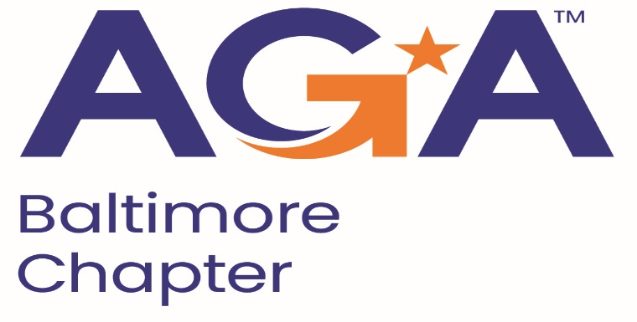

**Board of Directors Meeting Agenda**

September 11, 2024

11:00AM – 12:00PM

Call-in Number: 1-443-840-7262

Participant Code: 193 965 47#

1. **Call to Order**
   1. Shenika Smith, Johnny Ramsey, Masoud Najmabadi, Kristen Schnatterly, Richard Merritt, John Goodwin
2. **Review and Approval of Prior Minutes**
   1. John-Motion for Approval; Richard 2nd, Approval
3. **President’s Report** 
   1. Shenika has reached out to the committee’s for events dates for the chapter calendar.
4. **NCC Introduction and Update** 
   1. Reminder to committees to reach out to Kristen if you have question other chapters.
5. **Treasurer Update -Pending Mike** 
   1. Working with Bank to get access Mike K. name added
6. **Committee Updates**

* **Accountability**(Mike)
  + CCR Update in progress
* **Activities/Ace Reporting** (Lori)
* **Administration**(Kelly)
* **Awards** (Renee)
* **Bylaws** (Mike)
* **CGFM/Certifications** (Kristen and Aurelie)
  + Scholarships being announced, Fall information session, Emailed Meetings Committee to confirm date, Pricing the study guides for purchase
* **Communications/Webmaster** (Shenika)
  + Due Date 9/27, Distribution 10/11.
  + Website is up to date
  + Send request for distribute
  + Send a communication to members about Junk Emails
  + Johnny suggest sending an mailing about the communication methods
  + Masoud suggest sending list of members that don’t answer to call
  + Social media post to remind members to check emails
* **Community Service** (Angela)
* **Education** (John, Johnny, Kelly)
  + Met with Sponsorship to discuss upcoming meetings
  + Decided to not do September meeting
  + Will host December 4th meeting
  + Full Day Training, In Person
  + Education will meet with Meeting committee Friday
  + Kearney & Co
* **Meetings** (Megan)
* **Membership/Young Professionals** (Masoud and Geoff)
  + 42 suspended members, calling to get them to renew, explaining benefits
  + 11 new members that joined, include in newsletter, call member
  + Set up meeting to discuss recruitment and retention
* **Social Programs**(Mike)
  + No takers on Crab Feast
* **Sponsorships** (Rich)
  + No response from Colin
  + Requesting any information for POC
  + Johnny motion to approve, 2nd Kristen, Approved
  + Kearney

**VI. New Business**

Everything has been filed to renew sales tax 9/31