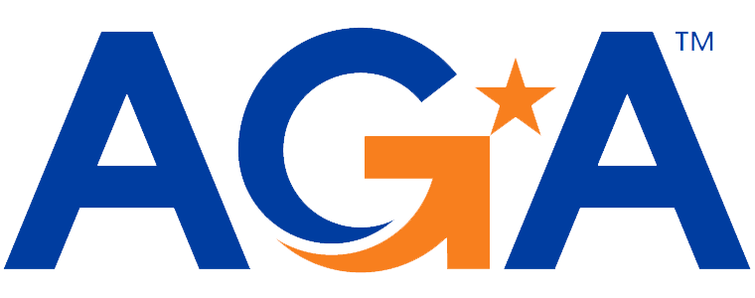

**Baltimore Chapter**

**Board of Directors Meeting Agenda**

September 6, 2023

2:00 – 3:00PM

Call-in Number: 1-443-840-7262

Participant Code: 321 425 192 #

1. **Call to Order**

*Michael Klausmeier, Jamie Richardson, Lori Lee, Kristen Schnatterly, Shenika Smith, Kyle Brincefield, Sarah Cherry, Amanda Merlino, Masoud Najmabadi, Kristina Poist, Renee Rawlins, Megan Salter, Kevin Lee, JoAnn Burnet, Angela Shields*

1. **Review and Approval of Prior Meeting Minutes**

Motion to approve, Masoud seconds. Minutes approved.

1. **President’s Report** 
   1. September 27, 2023 Training (flyer attached to email)
      1. 4 CPEs for the training.
      2. Jotform link will update with new date, Megan confirmed. Shenika has posted flyer to website.
      3. Emailing flyer to AGA members with the email blast.
      4. 3 required polling questions per CPE, we have 4 in case there is one missed.
         1. Megan needs the questions prior to the training in order to incorporate the questions into the program.
2. **NCC Introduction and Update**

* Find out when the DC AGA chapter trainings are being held so there are no conflicts between our chapters.
* Google drive, Renee never received the full access, Mike should look into the access to upload all of our information for this year.
* Planning meetings is a best practice, not all chapters are doing them but we are.
* Considering moving away from Zoom to Conference IO. Mike did not reply to national about moving to new platform, we can discuss moving to the new platform next year since we already paid for this years subscription for Zoom.

1. **2023-2024 Budget Discussion and Approval**

* Increased Meetings/Conferences in September and May.
* Typically the speakers should be put in the budget for the Education Expenses and not the Meetings/Conferences. Kevin will adjust the budget.
* Need an additional budget line item for communications for the Jotform application (included in the Webmaster line). August renewal of $99.37, budget at $100.
* Vote via email on approval of the budget.

1. **Committee Updates**

* **Awards** (Kristina and Angela)
  + Typical schedule, Scholarships and end of year awards to either board members or other members.
  + Scholarships starts around January to schools in the area. Angela/Kristina go through the applications and select the winners and are announced in April.
  + Letter for the Scholarships will include the dedication to Milt.
  + Shenika: Can we advertise the scholarships on Social media? Yes, Kristina will send Shenika information to post.
  + JoAnn: What schools do we send scholarships to? All of them in the Maryland area: Salisbury, Washington, Baltimore, UMBC, Stevenson, Loyola and more.
* **Activities/Ace Reporting** (Lori)
  + Loading the roster is the next thing on the agenda.
* **Bylaws** (Mike)
  + We have until October to complete these, Mike is working on them.
  + Found demographic information on AGA website, Amanda is working on this section for the CCR.
* **CGFM/Certifications** (Kristen and Aurelie)
  + Shenika asked for updates for CGFM on the website, Kristen sent out the information for the website to be added.
* **Communications/Webmaster** (Shenika)
  + Training and presidents message is posted, email will go out today. Social media posting will go out COB Friday.
  + Website is outdated, Shenika will be updating this and reaching out to board members for updates.
  + Domain has renewed, we will need to get a refund to Shenika and put the AGA card on the account for the future renewals.
  + Working on a feature for Milt.
* **Education** (Jamila, Kelly, Johnny, JoAnn)
  + No date for the May meeting yet, will discuss further.
* **Meetings** (Megan, Kyle)
  + Next training will be in February, trying for 8 hour CPEs.
  + If we want to link up with ISACA, they do their meetings in December and could request to do a joint meeting with them this year.
* **Membership** (Geoff and Masoud)
  + Masoud now has access to the website for the roster. If someone new joins, he will let the board know.
  + Masoud will let everyone know what the total member number is.
* **Social Events/Community Service** (Kathleen and Sarah)
  + October event as a possible date for the board members.
* **Sponsorships** (Colleen)
  + No updates.
* **Students and Young Professionals** (Renee)
  + Will be reaching out to schools to determine how they want us involved to talk about AGA and CGFM.
  + Amanda will be at Loyola next Tuesday and will leverage her time to speak about AGA. Coordinate with Renee to get some AGA supplies for the schools.

**VI. New Business**

* Did we decide not to join the DC/Montgomery chapter kick off social event on September 16, 2023 @ 11am in Arlington, VA? Masoud will let them know we do not currently have any interest, due to cost reasons (paying a percentage for all other people attending with not many of us joining the event).
* Bank account is in Renee’s name, will need to be updated to Mike’s name.