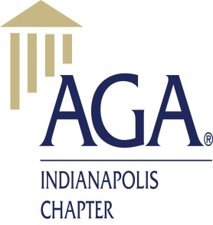

**Chapter Executive Council**

www.agacgfm.org/indianapolis

**April 10, 2019 / Conference Room 340R-1**

**Bridgeline 317-212-8100 PC code: 155280#**

***Committee Updates***

* President - Melissa Jacobs
* Secretary – Emily Blake
* Member question - I noticed while reviewing this report that the Chapter has an unrestricted reserve of around $48,000.00. I did not see any plans for that money. I would like to suggest that the Chapter fund several members to attend the National PDI as a good utilization of those funds.
* Cash is in CD’s
* Lots of expenses right now – don’t have much cash
* Meg noted
* Treasurer – Lindsay Harris
* Website – Katie Buck
* Ball state advertisement request

Discussion – Katie will send to Melissa and Emily to respond

* Awards - Tyneshia – got 3 scholarship apps
* End of year banquet planning – June Saturdays booked
* Group decided on Sunday in June
* If budget is higher than planned, will need to vote on difference
* Education - Tara – estimate $4300 income from fall PDI
* Discussion – consider price change for next program year
* Networking - LaTrice
* Rescheduling SES panel
* Community service – Catherine Henshaw/Stevie Lynch
* Saturday April 27 Mutt Strut
* Chapter points – Virginia Smith-Milan
* Made platinum
* Can still earn points
* CGFM – Dan Neumann
* Scheduling CGFM networking lunch
* Received proclamation from City of Lawrence
* Before end of school year – going to meet with IU student chapter
  + Suggest connect with Bobby Derrick
* Social – Clarence Hill
* Punch bowl event successful
* Amanda Pierce – Board member
* Sent email for Treasurer elect bios for vote
* All other slots are uncontested